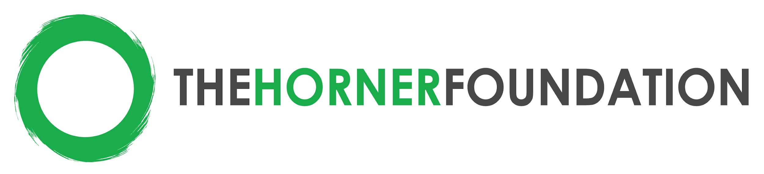

2022-2024 Funding Criteria: Youth Food Justice and Girls Empowerment
Alameda & Contra Costa Counties, Bay Area, CA

Targeted Grant Size: $40,000 to $50,000 USD over 2 years

Strategy: For the past several years, the Horner Foundation has worked at the intersection of youth development and food justice, with the goal of empowering youth to learn about and take action to localize their food system and increase food security for all. Our 2022-2024 funding will continue this mission, with an increased emphasis on youth-led and youth-organized projects. Youth outcomes are maximized when youth are able to envision, organize and execute projects alongside supportive adult mentors and allies. The Foundation aims to provide more funding directly to youth in the Bay Area, so that they can make a measurable difference in their communities. Also, we are continuing our newer funding focus to empower young women and girls to access experiential learning and leadership opportunities in the Bay Area. If you match the criteria listed below, we encourage you to submit a letter of intent (LOI). More information about the LOI and application process can be found at: https://www.thehornerfoundation.org/

Types of Organizations that should apply:
- Nonprofit organizations serving youth in Alameda and Contra Costa Counties
- Emphasis on under-resourced youth aged 10-19 years (middle & high school students)
- Organization must have interest in improving their capacity to collect, understand, and use data for ongoing improvements and stronger results

Funding Focuses:
- Youth Food Justice
  - Organizations working at the intersection of youth development and food justice
  - Grants that work to elevate youth voice will be prioritized. This may include mini-grant programs for youth, where one organization or collective of organizations build on existing infrastructure or create a new program for youth to apply for / receive mini-grants. It is understood that many youth development programs provide adult mentoring and structured opportunities for youth to participate meaningfully.
2. Girls Empowerment
  - One organization or collection of organizations

